Icenter media design
Overall design
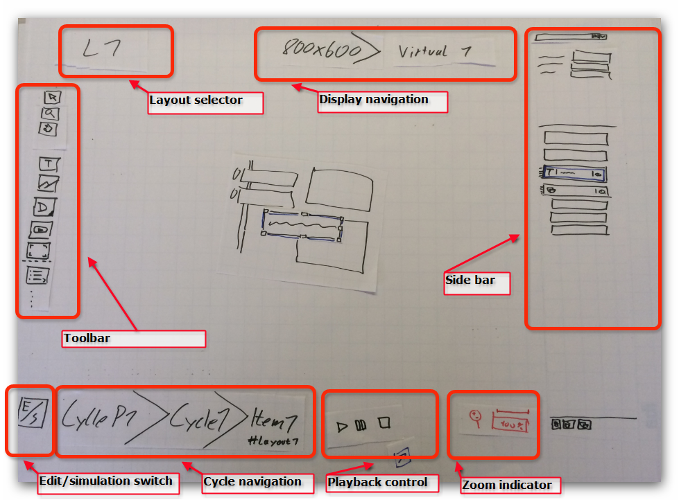

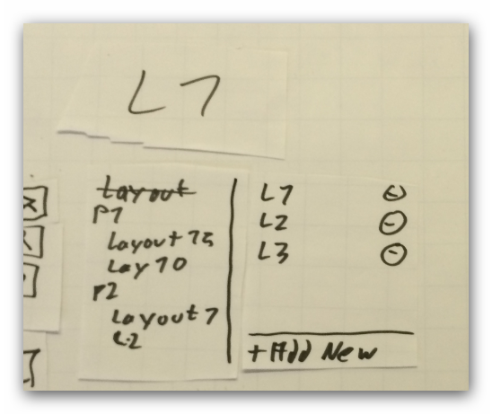
- Layout selector
  - Is in the top left corner
  - Is half transparent if mouse is not over
  - If clicked opens the layout administration control

- Toolbar
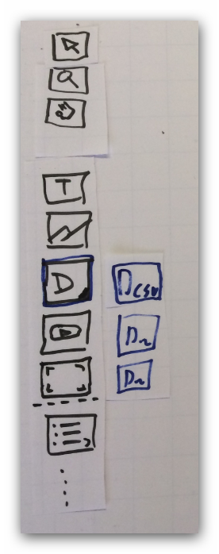
  - Arrow
    - Allows you to select and modify existing elements
  - Magnifier
    - Allows you to zoom the current layout view
    - Draw a rectangle, left click to zoom in
    - STRG + left click to zoom out
    - Right click to context menu (fit to screen, 1:1)
  - Hand
    - Allows you to move (“panning”) the whole view
    - Triggered by holding key <SPACE>
  - Static text
    - Allow you to draw a rectangle and enter custom text
  - Picture
    - Allows you to draw a rectangle and select a picture from the media administration control
  - Dynamic text
    - Allows you to draw a rectangle and select a text field from dictionary in dictionary selector
    - Is able to pull out the specialized dynamic text tools (e.g. dynamic text from CSV)
  - Video
    - Allows you to draw a rectangle and select a video from the media administration control
  - Place holder for media
    - Allows you to draw a rectangle and give it a name
  - Template section
    - List of predefined group of elements

- Cycle navigation
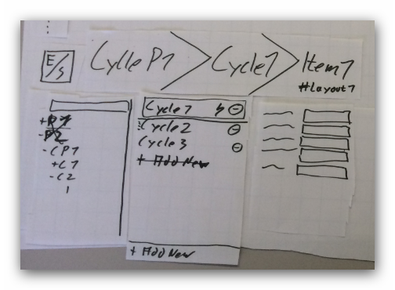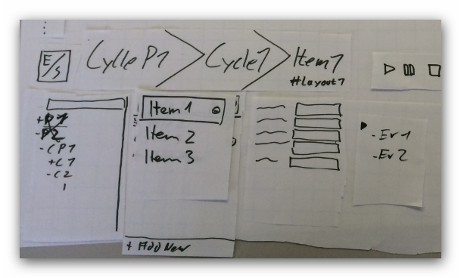

- Edit/simulation switch
  - Switches between cycle navigation and simulator
- playback controls
- zoom indicator
- display navigation
  - physical screen selector
  - virtual display selector
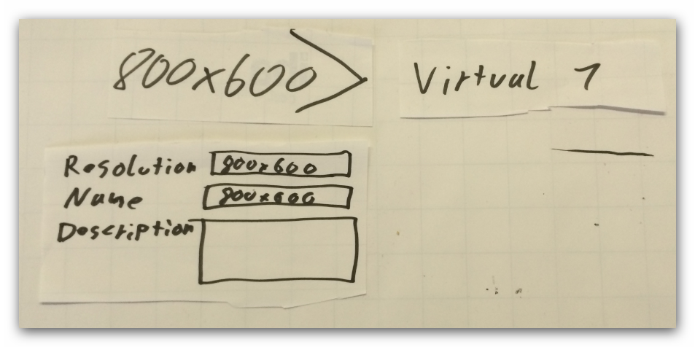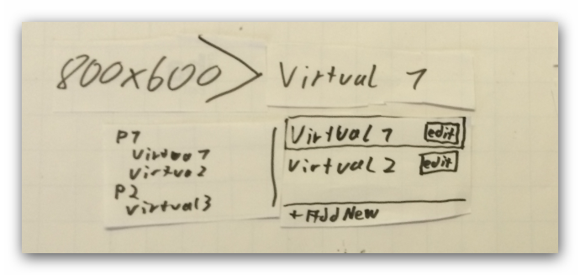

- side bar
  - is able to display its contents vertically and side by side; it is collapsible
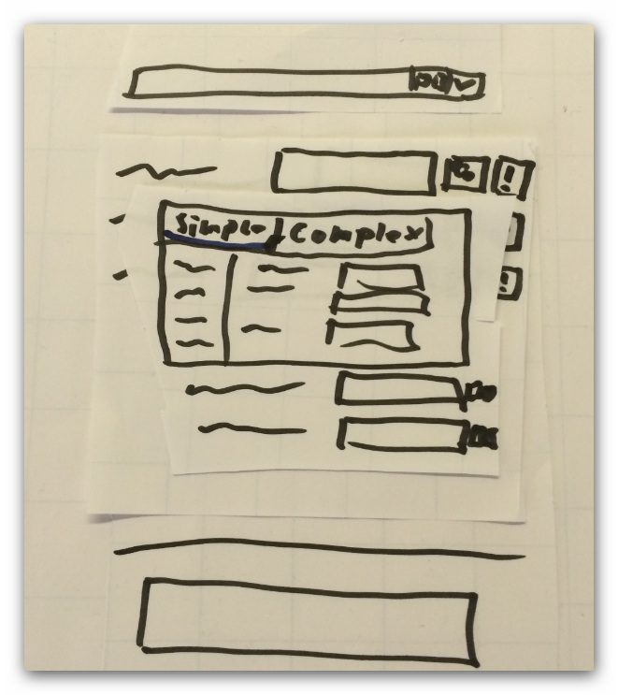
  - element property editor
  - layout outline editor
    - duplicate, delete, group

- simulator
  - it is possible to show the simulator in an external window
    - re-enables simultaneous editing
    - displays the actual rendering (TFT rendering engine) and the simulator controls
    - playback controls in a separate windows
    - pop-in button to integrate it again
  - simulator controls
    - timeline which displays all cycle packages with its cycles and the cycle items over time
    - it is possible to move the time slider to a specific time
    - select a cycle to display
    - re-arrange cycle items and cycles
    - and adjust the time duration for cycle items
    - transitions (animations) between cycle items
    - zoom controls for time scale
    - indicates event cycles
    - highlighting of current cycle
    - highlighting cycle packages based on selected virtual displays
    - it is possible to show/hide unused cycle packages and cycles
    - icon to enable the event simulation mode
      - re-arranges the cycle items depending on the event and condition data
      - playback is now adjusted to the defined situation
    - presenting list of all relevant conditions and events based on all relevant items of the project and enables to define values in the time line for each

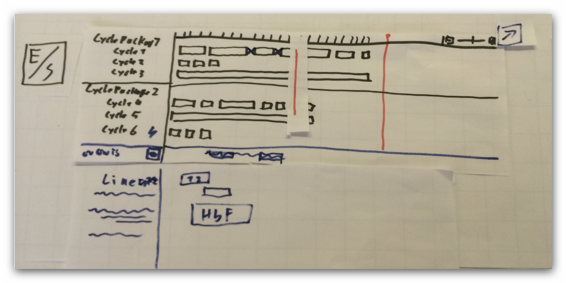

Popups
- Dictionary selector
- media administration control
- Layout administration control
  - Allows you to select existing, add new, add predefined and remove existing layout

Project administration control
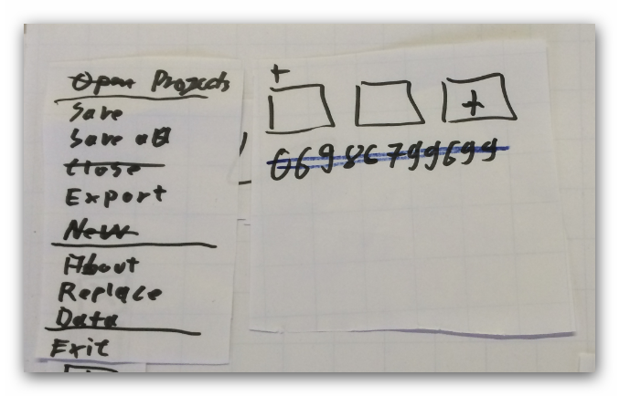
- Projects
  - Recently used projects
  - New project
- Save
- Save as
- Export
- About
- Replace
- Dummy Data
- Exit

Conditions, Criteria:
- Item category/type
- Compare type
- Value
- Operator
